**Habitability of Exoplanets Around M – dwarf Stars**

Nick Luedtke

University of Illinois at Urbana-Champaign

Department of Astronomy

Abstract

This paper examines the habitability of exoplanets around M-dwarf stars. We discuss the dynamics of the protoplanetary disk and the accretion of exoplanets themselves. Then, all the main types of detection techniques are discussed, radial velocity, transit events, and microlensing. Recently our main source of data has been from transit events. The probability of life is much higher around main sequence stars because of their lifespans and luminosities compared to other types of stars. Then we investigate types of main sequence stars, specifically M-dwarf stars. Given some disadvantages, M-dwarfs are fainter, therefore their light curves will have a larger dip in luminosity when planets pass in front of the stars, meaning the planet is easier to detect. Exoplanets will also pass in front of the star more often making it easier to deduce whether the planet will be in the stars habitable zone. With Kepler, the goal of determining the frequency of planets around stars was achieved and now we set off in determining the habitability of exoplanets around M dwarf stars.

Introduction

Over the past decade, the new field of exoplanets has exploded into one of the most popular topics in astronomy. In 2009, NASA launched the Kepler observatory into space, beginning a new era of space exploration: the search for Earth-like planets orbiting other stars. Kepler surveyed over 150,000 stars in search of these planets. It detects planets by looking for periodic dips in the brightness of stars. The Kepler satellite continuously surveyed a selected area of 10 degrees by 10 degrees in the Cygnus-Lyra region of the Galaxy to determine the proportion of stars, particularly main sequence stars, showing the planetary transits using light curves (Rhodes and Budding, 2014). To get an idea of how powerful the detectors of the telescope are, consider that from up in space, Kepler could detect someone in a small town turning off an outside light at night.

Kepler has been placed in what is called an "Earth trailing" orbit around the sun. In this orbit, a little wider and slower than our own orbit, the spacecraft requires 371 days to complete one circuit. Each day Kepler falls farther and farther behind Earth, eventually opening a distance of tens of millions of miles. This uncommon orbit, used for the first time with the Spitzer infrared space telescope in 2003, has advantages for astronomical telescopes. One is that Earth does not obstruct their view of the sky. The spacecraft does not need to be boosted periodically to maintain its altitude above Earth. Earth trailing orbits are also very fuel-efficient orbit, requiring less energy (smaller rocket, lower cost) to reach than the L2 Lagrange point, which is where Kepler was originally planned to go. Expect these Earth-trailing orbits to become a popular choice for future astronomy missions.

One year into Kepler’s three and one half year mission approximately 3000 planetary transits had been recorded and analyzed. Mostly these are attributed to planets larger than the Earth, although about 10% of candidates are comparable in size to the Earth. The majority of known examples are smaller than Jupiter, although around 10 percent are of about the same size or larger. About 5% have been located in the ‘habitable zones’ of their parent stars. NASA announced the positive identiﬁcation of Earth-sized planets towards the end of 2011. It should also be noted that a fair proportion of initially announced planet ﬁnds, perhaps more than ∼30% have since been marked as false positives (Rhodes and Budding, 2014).

In this article, we will address the formation of exoplanets and its relationship with stars. As a star begins to form, the protoplanetary disk around it contains a collection of debris and other gases that did not fall into the protostar. The debris and gas begin to accrete and eventually will create either rocky planets, like Earth or Mars, or gas giants, like Jupiter or Neptune. In the classical picture developed to explain the Solar System, the process starts with a disk of small solids having just enough mass to reproduce objects in the Solar System. Collisional processes merge small solids into km-sized or larger planetesimals, then Mars-mass protoplanets, and finally Earth mass planets (Kenyon et al, 2016). These processes are violent and tear apart the protoplanets many times while adding and ejecting new material. The ejected material later forms moons by the same process on a smaller scale. Therefore, in these early stages the planets’ masses change often and rapidly. When the star they are orbiting finally begins hydrogen fusion, radiation pressure produces an initial “kick” which blows away most, if not all of the debris in the accretion disk revealing the star and its protoplanets. During this time, the protoplanets and their satellites are subject to heavy bombardment by debris. After the bombardment period has ended, the final structure of the new solar system is exposed.

Exoplanets can be detected in a number of ways, including transit events, radial velocities, microlensing, imaging, and pulsar timing. Today, transit events are the main method of detection. Light curves produced by these transits show dips in the star’s brightness as the object transits in front of it. However, we will briefly discuss the other types of exoplanet detection techniques. Pulsar timing was used in 1992 by Aleksander Wolszczan and Dale Frail to detect the first confirmed exoplanets. These exoplanets orbit a pulsar, which is a rapidly rotating neutron star. As they spin, pulsars emit intense electromagnetic radiation that is detected on Earth as regular and precisely timed pulses. By analyzing any irregularities in the timing, astronomers can determine if there is a planet orbiting it. Direct imaging of exoplanets is extremely challenging, and in most cases impossible. Being small and dim, planets are easily lost in the brilliant glare of the stars they orbit. Nevertheless, even with existing telescope technology there are special circumstances in which a planet can be directly observed. Microlensing is the only known method capable of discovering planets at truly great distances from the Earth. Exoplanets and their stars that are normally not visible or dim are magnified by stars or other massive objects in front of them. The radial velocity method relies on the fact that a star does not remain completely stationary when it is orbited by a planet. It moves, ever so slightly, in a small circle or ellipse, responding to the gravitational tug of its smaller companion. When viewed from a distance, these slight movements affect the star's normal light spectrum.

Searches for habitable planets must take the type of host stars into account. Giants and super giants have relatively short life spans. White dwarfs are too old because the event that made them into white dwarf, the expulsion of their surface layers, would have likely destroyed any form of life on a planet orbiting. Therefore we are left with regular main sequence stars and to narrow it down to Sun-like stars because we know the conditions for life around Sun-like stars the best. The Drake equation for calculating the number of intelligent, communicative civilizations is famously uncertain, with estimates of the civilization incidence per habitable planet ranging from 10−5 to arbitrarily small values. Combined with our estimates of the number of Earth-like planets and the fact of our existence, this would result in 1 to 1015 civilizations in the Universe and 1 to 104 in the Milky Way at the present time. (Behroozi and Peeples, 2015). The more planets we observe with missions like Kepler, the better odds we have of finding another civilization out there in the unknown.

The trend in data taken of occurrence rates so far shows a correlation between terrestrial planets within 1 AU and solar-type stars. Rocky planets within 1 AU appear to be fairly common companions to solar-type stars. Here, we focus on a comprehensive analysis of Kepler data which provides a detailed estimate for the occurrence rate of Earth-mass planets inside 1 AU (Kenyon et al., 2016). Assuming the occurrence of Earth-like planets is this common we can reasonably assume that this would be a logical place to search for life on another planet. M-type stars have been found to have many exoplanets in recent studies. The atmosphere must be able to withstand the harsh environments of space and hold in the elements necessary for life and the star must keep the planet at a suitable temperature.

Formation of Exoplanets

Protoplanetary Disks

The formation and early evolution of stars are intimately coupled to the properties of their accompanying circumstellar disks of gas and dust. These disks also provide the material reservoirs for the assembly of planetary systems. Angular momentum conservation dictates that a collapsing molecular cloud core with some initial rotation will result in both a central protostar and a flattened circumstellar disk (Andrews et al., 2005). The protoplanetary disk may also be thought of as an accretion disk for the star itself, because gases and other material fall from the inner edge of the disk onto the surface of the star. But this process should not be confused with the accretion process which builds up the planets themselves.

Protostars mainly form from interstellar clouds consisting primarily of molecular hydrogen. Conservation of angular momentum causes the rotation to increase as the nebula radius decreases. This rotation causes the cloud to flatten out—much like forming a flat pizza out of dough—and take the form of a disk. The initial collapse takes about 100,000 years. After that time the star reaches a surface temperature similar to that of a main sequence star of the same mass and becomes visible. Accretion of gas onto the star continues for another 10 million years, before the disk disappears, perhaps being blown away by the new star's solar wind, or possibly ceasing to emit radiation after accretion has ended. The oldest protoplanetary disk yet discovered is 25 million years old.

The mass of a typical proto-planetary disk is dominated by its gas, however, the presence of dust grains has a major role in its evolution. Dust grains shield the mid-plane of the disk from energetic radiation from outer space that creates a dead zone in which the MRI (magnetorotational instability) no longer operates.

Accretion

Disks around pre–main-sequence stars are the likely sites of planet formation. As such, they have been targets of extensive research over the past two decades. Surveys of continuum emission at infrared and millimeter wavelengths have established that 50% of all classical T Tauri stars (CTTSs; ages less than 3 Myr) have disks with typical masses of 103 to 101 Msun, sufficient to form a planetary system like our own (Evans II et al., 2003). Electrostatic and gravitational interactions cause the dust and ice grains in the disk to accrete into planetesimals. This process acts against the stellar wind, which drives the gas out of the system, and gravity (accretion), which acts to pull material into the central star.

It is thought that moons of Jupiter, Saturn, and other planets formed as smaller, circumplanetary analogs of the protoplanetary disks. The formation of planets and moons in geometrically thin, gas-rich and dust-rich disks is the reason the planets are arranged in an ecliptic plane.

Detection Techniques

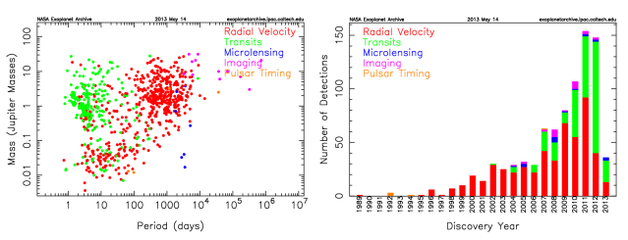

Figure 1.) Left: Plot of planetary mass vs. orbital period for confirmed exoplanets. Right: Histogram of exoplanets discovered as a function of time. Different colors represent the different detection techniques. (Akeson et al., 2013)

Radial Velocity

A star with a planet in its system will have its own small orbit because of the planet's gravity. This causes variations in the speed with which the star moves toward or away from Earth. The radial velocity can be calculated from the displacement of the parent star's spectral lines due to the Doppler effect. The radial-velocity method measures the variation of the star’s spectral lines in order to check for the presence of the planet.

The radial-velocity method was the most wide used technique used by astronomers, until about 2014. It is also known as Doppler spectroscopy. The method is distance independent, but requires high signal-to-noise ratios to achieve high precision, and so is generally only used for relatively nearby stars to find lower-mass planets. It is also not possible to simultaneously observe many target stars at a time with a single telescope. Planets of Jovian mass can be detectable around stars up to a few thousand light years away. This method easily finds massive planets that are close to stars. Modern spectrographs can also easily detect Jupiter-mass planets orbiting 10 astronomical units away from the parent star, but detection of those planets requires many years of observing.

Planets around low mass stars are easier to detect, for two main reasons: these stars are more affected by gravitational tugs from planets, and the other, is that low-mass main-sequence stars generally rotate fairly slowly. Fast rotation makes spectral-line data unclear because half of the star quickly rotates away from observer's viewpoint while the other half approaches. Detecting planets around more massive stars is easier if the star has left the main sequence, because leaving the main sequence slows down the star's rotation. However, rotational broadening makes it hard to measure line shifts.

Although the radial velocity of a star only gives a planet's minimum possible mass, if the planet's spectral lines can be distinguished from the star's spectral lines then the planet’s radial velocity can be found. This allows for the measurement of the planet's actual mass. This also rules out the problem of false positives, and provides data on the planet that allows astronomers to determine its composition. The main issue is that such detection is only possible if the planet orbits around a relatively bright star and if the planet reflects or emits a lot of light.

Transit Events

While the radial velocity method gives data on a planet's mass, the transit method can determine the planet's radius. If a planet transits in front of its parent star, then the flux of the star drops by a small amount, shown in Figure 2 below; the amount of dimming depends on the relative sizes of the star and the planet.

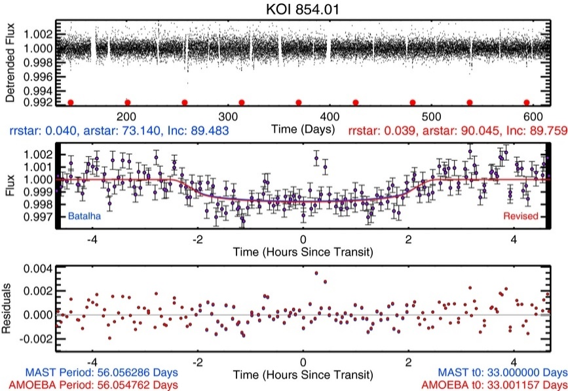

Figure .) Top: Light curve with transit times marked by red dots. Middle: Light curve phased to the best-fit period. Shows the drop in flux as the planet transits the star. (Dressing and Carbonneau, 2013)

This method has two main disadvantages. First, the planet’s transits are only observable when the planet's orbit is aligned perfectly from the astronomer’s viewpoint. The probability of a planetary orbital plane being directly in the line-of-sight to a star is low even for planets with small orbits, and this probability gets lower as the orbits get larger. The transit method cannot guarantee that any particular star is not a host to planets. However, by scanning large areas of the sky containing thousands or even hundreds of thousands of stars at once, transit surveys can find more extrasolar planets than the radial-velocity method.

The second disadvantage of this method is a high rate of false detections. A star with a single transit detection needs to have more confirmation, generally from the radial-velocity method. The radial velocity method is especially necessary for larger planets as objects of that size encompass not only planets, but also brown dwarfs and even small stars. As the false positive rate is very low in stars with two or more planet candidates, they often can be validated without extensive follow-up observations.

The most important advantage of the transit method is that the radius of the planet can be determined from the light curve. When combined with the radial-velocity method (which determines the planet's mass) astronomers can determine the density of the planet, and therefore learn something about the structure of the planet. Planets that have been studied by both methods are the best-categorized of all known exoplanets.

The transit method also makes it possible to study the atmosphere of the transiting planet. When the planet transits the star, light from the star passes through the uppermost parts of the atmosphere of the planet. By studying the stellar spectrum carefully, astronomers can detect elements present in the planet's atmosphere.

Microlensing

Gravitational microlensing occurs when the gravitational field of a foreground object acts as a lens to magnify the light of a background star. This effect occurs only when the two objects are almost exactly aligned. Lensing events are brief, sometimes lasting for weeks or days, as the two objects and Earth are all moving relative to each other. More than a thousand such events have been observed over the past ten years.

If the foreground lensing star has a planet, then that planet's own gravitational field can make a detectable contribution to the lensing effect. Since that requires a highly improbable alignment, a very large number of distant stars must be continuously monitored in order to detect planetary microlensing contributions at a reasonable rate. This method is most fruitful for planets between Earth and the center of the Galaxy, as the galactic center provides a large number of background stars.

A notable disadvantage of the method is that the lensing cannot be repeated, because the chance alignment never occurs again. Also, the detected planets will tend to be several kiloparsecs away, so follow-up observations with other methods are usually impossible. In addition, the only physical characteristic that can be determined by microlensing is the mass of the planet, within loose constraints.

The main advantages of the gravitational microlensing method are that it can detect planets with face-on orbits from Earth's viewpoint, and it can detect planets around very distant stars. When enough background stars can be observed with enough accuracy, then the method should eventually reveal how common Earth-like planets are in the Galaxy.

Probability of Life

Main Sequence

When astronomers think of planets as habitable they tend to look at the age and evolutionary stage of the star it is orbiting, because a lot can be deduce from this information. Giant and subgiants would die too fast to be suitable hosts for life. White dwarfs are far too old to host life, since the event that lead to their creation of the white dwarf itself. Neutron stars form from supernovae, thus any planets orbiting that star would become uninhabitable. Astronomers settle to the middle group of these stars, known as the Main Sequence.

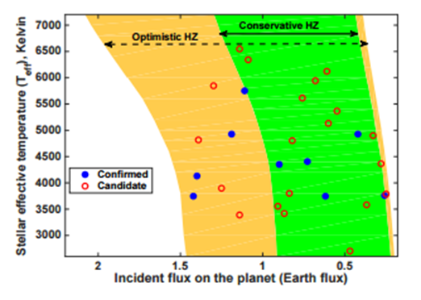Main sequence stars are ideal hosts for life bearing exoplanets because of their luminosities, and their lifespan. A typical main sequence star has an average lifetime of about 10 billion years and its luminosity is comparable to our Sun. Therefore the luminosity is dominated by optical and UV wavelengths. The Kepler mission has a primary science goal of determining the frequency of terrestrial planets in the Habitable Zone: usually defined as the region around a star where water can exist in a liquid state on the surface of a planet with sufficient atmospheric pressure (Kane et al., 2016). This habitable zone definition can be split into two categories: Optimistic Habitable Zone and Conservative Habitable Zone. Thus, it makes sense to talk about a “conservative” Habitable Zone (0.99–1.7 AU) and an “optimistic” Habitable Zone (0.75–1.8 AU). These limits are shown in the figure above as a function of the flux from the star normalized to the flux at Earth’s orbit. The boundaries vary for different stellar types because of the different albedo of an Earth-like planet at different wavelengths of stellar irradiation (Kane et al., 2016).

Figure .) Stellar effective temperature as a function of incident flux for confirmed and unconfirmed candidates. (Kane et al., 2016)

M-dwarfs and Earth-like Planets

Advantages

First, M dwarfs are small. This means that an Earth-sized planet crossing in front makes a deeper transit around an M dwarf than around a G dwarf like the Sun. Second, M dwarfs are much fainter (0.015 times the Sun’s luminosity) which means that the habitable-zone orbits closer to the star. A smaller orbit means a shorter period, which indicates that said planet will cross in front of the star much more frequently. The combination of a shorter orbital period, an increased transit probability, and a deeper transit depth greatly reduces the difficulty of detecting a habitable planet and has motivated numerous planet surveys to target M dwarfs. (Dressing and Charbonneau, 2013). Since Kepler finds small planets by phase-folding data (essentially adding the signal from all the observed transits together), observing ~5 times as many transits for each planet means that we have already found most of the Earth-sized “habitable zone” planets transiting M dwarfs in the Kepler sample already.

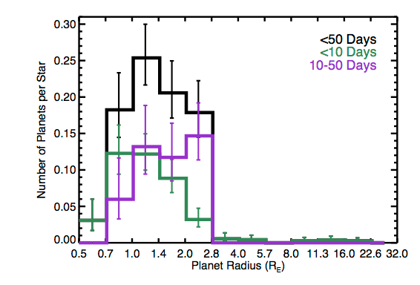Second, studies of the solar neighborhood have revealed that M dwarfs are 12 times more abundant than G dwarfs. The abundance of M dwarfs, combined with growing evidence for an increase in the planet occurrence rate at decreasing stellar temperatures, implies that the majority of small planets may be located around the coolest stars. (Dressing and Charbonneau, 2013). The occurrence rate of planets with radii between 0.5 and 4 Earth radii and periods shorter than 50 days is found to be 0.86 planets per M dwarf: a planet for almost every M dwarf in the galaxy. Figure 4 shows the planet occurrence rate around M dwarfs as a function of planet radius and orbital period. The rate drops off steeply at 2.8 Earth radii, showing that Neptune to Jupiter sized planets in less than 50 day periods around M dwarfs are very rare.

Figure .) Planet occurence rate as a function of planet radius for all candidates (black) and candidates with orbital periods shorter than 10 days (green) or between 10 and 50 days (purple). (Dressing and Charbonneau, 2013)

Issues with M-dwarfs

There have been many studies and papers about stars with habitable planets. However, some fairly recent research into the subject has led to the hypothesis that M dwarfs might be good candidates for Earth-like planets. Although early work suggested that a hypothetical planet in the habitable zone (the range of distances at which liquid water could exist on the surface of the planet) of an M dwarf would be inhospitable because the planet would be tidally locked and the atmosphere would freeze out on the dark side of the planet, more recent studies have been more optimistic. For example, it was shown that if there was enough carbon dioxide present that it could prevent the atmosphere from freezing. Additionally, a tidally locked planet could be in a partially habitable “Eyeball Earth” state in which the planet is mostly frozen but has a liquid water ocean at the substellar point. Moreover, planets orbiting M dwarfs might become trapped in spin–orbit resonances like Mercury instead of becoming spin-synchronized (Dressing and Charbonneau, 2013).

A second concern for the habitability of planets orbiting M dwarfs is the possibility of strong flares and high UV emission in quiescence. Although a planet without a magnetic field could require years to rebuild its ozone layer after experiencing strong flare, the majority of the UV flux would never reach the surface of the planet. Accordingly, flares do not present a significant obstacle to the habitability of planets orbiting M dwarfs. Furthermore, the specific role of UV radiation in the evolution of life on Earth is uncertain. A baseline level of UV flux might be necessary to spur biogenesis, yet UV radiation is also capable of destroying biomolecules (Dressing and Charbonneau, 2013).

Conclusions

Current understanding

The Kepler mission has provided an enormous amount of data and discoveries that have enabled statistical studies of exoplanets in the terrestrial regime. Although the Kepler’s primary mission duration was not as long as desired, the duration was sufficient for the orbital period sensitivity to reach into the HZ of the host stars. The primary mission goal of Kepler was thus achieved and has provided important information into the frequency of terrestrial planets in the HZ of late-type stars.

We understand that star formation takes an important role in the formation of planets. As a star forms, it starts accreting material from its protoplanetary disk but, also inside the disk where planetesimals begin to form. These planetesimals collide and become bigger and bigger until they become planets. Then the star, once it reaches the hydrogen burning phase, the beginning of the main sequence, it blows away most if not all of the un accreted dust and gas in the system by stellar wind processes.

The main method of detection, transit events, we can detect drops in luminosity as a planet passes in front of it. This results in light curves with periodic dips in their intensities which show the orbital period of the planet or possibly multiple planets. There is another way of doing essentially the same thing using gravitational microlensing. Gravitational microlensing helps astronomers see objects further away, or objects that would be otherwise blocked by another.

Next we discuss the habitability of planets around stars ignoring some cases which are unlikely. All that we are left with are Main sequence stars, are ideal hosts for life because of their luminosities and their lifespan. M dwarfs in particular are appealing search targets because they tend to have more possibilities of having more than one planet around them, therefore a higher possibility of life or a habitable world. Possible issues with M dwarf planets include the possibility that they could be tidally locked and the atmosphere would freeze out on the dark side, or the star could emit strong flares and high UV emission.

Future endeavors

The relatively high occurrence rate of potentially habitable planets around cool stars bodes well for future missions to characterize habitable planets because the majority of the stars in the solar neighborhood are M dwarfs. Given that there are 248 early-M dwarfs within 10 pc, estimates say that there are about nine Earth-size planets in the habitable zones of nearby M dwarfs that could be discovered by future missions to ﬁnd nearby Earthlike planets.

Although M dwarfs are intrinsically fainter than solar-type stars, 75% of the stars within 10 pc are M dwarfs. These stars would be among the best targets for future spectroscopic investigations of potentially habitable rocky planets due to the small radii and apparent brightness of the stars. (Dressing and Charbonneau, 2013)

Multiple separate projects are already monitoring nearby M dwarfs, and a host of new telescopes and satellites are in the works to spot planets orbiting them, including NASA's Transiting Exoplanet Survey Satellite (or TESS set to launch in 2017). These efforts make the imminent discovery of potentially habitable M dwarf planets a near certainty. Whether all those bodies will actually prove to be habitable, however, is much less clear: the same sun like properties that make promising M dwarf planets so easy to find may also preclude the possibility for life on those worlds.

The Transiting Exoplanet Survey Satellite (TESS) is an Explorer-class planet finder. In the first-ever spaceborne all-sky transit survey, TESS will identify planets ranging from Earth-sized to gas giants, orbiting a wide range of stellar types and orbital distances. The principal goal of the TESS mission is to detect small planets with bright host stars in the solar neighborhood, so that detailed characterizations of the planets and their atmospheres can be performed.

TESS will monitor the brightnesses of more than 200,000 stars during a two year mission, searching for temporary drops in brightness caused by planetary transits. TESS is expected to catalog more than 1,500 transiting exoplanet candidates, including a sample of ∼500 Earth-sized and ‘Super Earth’ planets, with radii less than twice that of the Earth. TESS will detect small rock-and-ice planets orbiting a diverse range of stellar types and covering a wide span of orbital periods, including rocky worlds in the habitable zones of their host stars.

MOVED:

Tidally locked planets orbiting M-dwarfs face unique challenges to their atmospheric stability. The atmosphere may “collapse” if the volatile inventory freezes out and becomes trapped on the night side. The atmosphere is also subject to erosion by stellar winds, which are denser and faster for M-dwarfs than Sun-like stars. (Kreidberg and Loeb, 2016).

**References**

Akeson, R.L., Chen, X., Ciardi, D., Crane, M., Good, J., Harbut, M., Jackson, E., Kane, S.R., Laity, A.C., Leifer, S., others, 2013. The NASA exoplanet archive: data and tools for exoplanet research. Publications of the Astronomical Society of the Pacific 125, 989.

Dressing, C.D., Charbonneau, D., 2013. The Occurrence Rate Of Small Planets Around Small Stars. The Astrophysical Journal 767, 95. doi:10.1088/0004-637X/767/1/95

Evans II, N.J., Allen, L.E., Blake, G.A., Boogert, A.C.A., Bourke, T., Harvey, P.M., Kessler, J.E., Koerner, D.W., Lee, C.W., Mundy, L.G., others, 2003. From Molecular Cores to Planet-forming Disks: An SIRTF Legacy Program. Publications of the Astronomical Society of the Pacific 115, 965.

Kane, S.R., Hill, M.L., Kasting, J.F., Kopparapu, R.K., Quintana, E.V., Barclay, T., Batalha, N.M., Borucki, W.J., Ciardi, D.R., Haghighipour, N., Hinkel, N.R., Kaltenegger, L., Selsis, F., Torres, G., 2016. A Catalog of Kepler Habitable Zone Exoplanet Candidates. ArXiv e-prints 1608.00620

Kenyon, S.J., Najita, J.R., Bromley, B.C., 2016. Rocky Planet Formation: Quick and Neat.

Rhodes, M.D., Budding, E., 2014. Analysis of selected Kepler Mission planetary light curves. Astrophysics and Space Science 351, 451–471.